KADJEBI DISTRICT ASSEMBLY

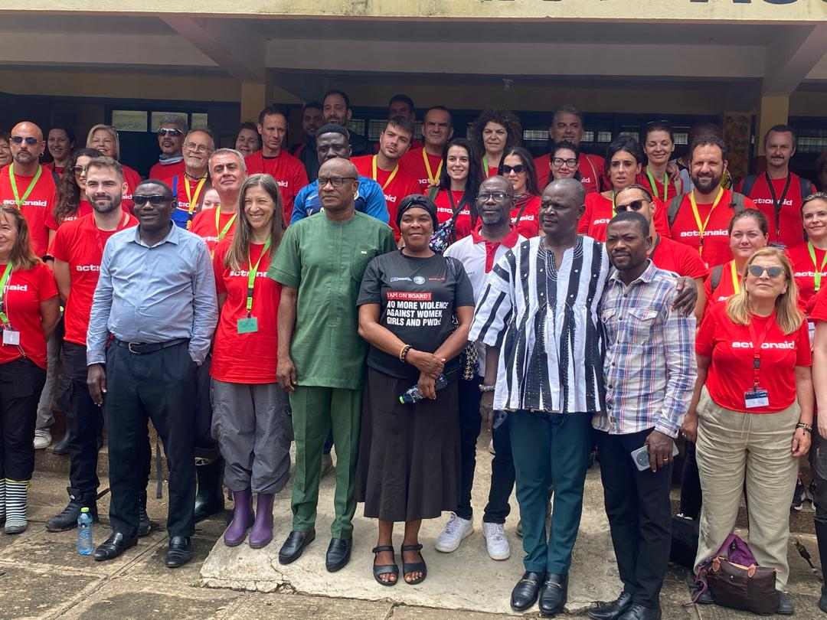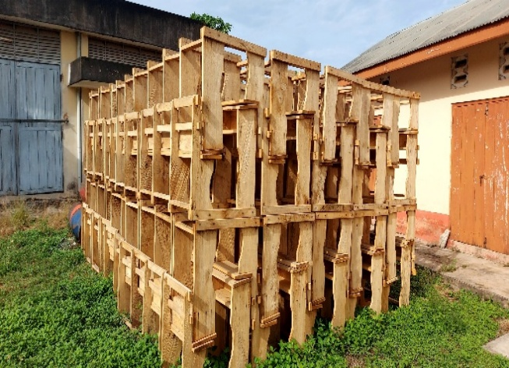

2026 COMPOSITE ANNUAL ACTION PLAN

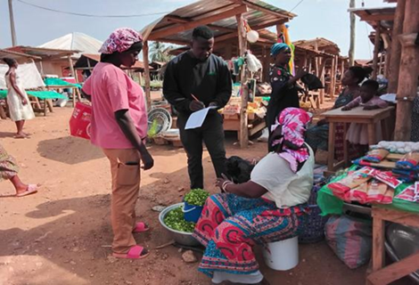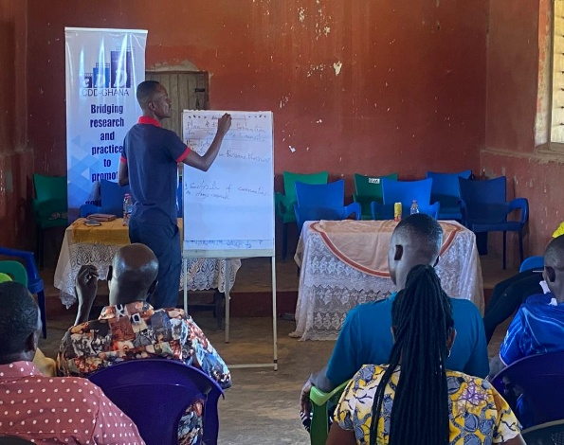

DPCU
OCTOBER, 2025

FORWARD
The 2026 Annual Action Plan of the Kadjebi District Assembly has been developed in accordance with national legal and policy frameworks guiding local-level development planning, including the National Development Planning (System) Act, 1994 (Act 480), the National Development Planning (System) Regulations, 2016 (L.I. 2232), and the Local Governance Act, 2016 (Act 936). As a Planning Authority, the Assembly uses this Plan to translate the goals and strategies of the Medium-Term National Development Policy Framework (MTNDPF, 2026–2029) into actionable programmes and projects tailored to the district’s development priorities.
Prepared by the District Planning Coordinating Unit (DPCU) in collaboration with stakeholders and development partners, the Plan seeks to improve the quality of life of the people in Kadjebi while contributing to national goals of prosperity, equality, environmental sustainability, and security. A total of one hundred and twenty-five (125) programmes and projects have been outlined under thematic areas such as Economic Development, Social Services, Infrastructure, Environment and Sanitation, and Management and Administration.
Successful implementation will depend on strong collaboration among the District Assembly, partners, and community stakeholders, supported by effective coordination, monitoring, and evaluation from the DPCU. The Plan is structured into six chapters, covering the district profile, development issues, goals and objectives, the composite action plan, monitoring and evaluation arrangements, and a communication strategy. Overall, the 2026 Action Plan reaffirms the Assembly’s commitment to inclusive and sustainable development for the people of Kadjebi District.

TABLE OF CONTENT

FORWARD ii
TABLE OF CONTENT iii
LIST OF TABLES iii
LIST OF FIGURES iv
EXECUTIVE SUMMARY v
CHAPTER ONE 1
GENERAL INTRODUCTION 1
DISTRICT PROFILE 1
CHAPTER TWO 15
KEY DEVELOPMENT PRIORITIES 15
CHAPTER THREE 18
DEVELOPMENT PROJECTIONS AND GOALS 18
CHAPTER FOUR 22
COMPOSITE ANNUAL ACTION PLAN - 2026 22
COMPOSITE ANNUAL ACTION PLAN – 2026 23
CHAPTER FIVE 36
MONITORING AND EVALUATION ARRANGEMENTS 36
CHAPTER SIX 38
DEVELOPMENT COMMUNICATION STRATEGY 38

LIST OF TABLES
Table 1: Age Distribution of Population by Sex 4
Table 2: Health Facilities in Kadjebi District 8
Table 3: GHS Sub-Districts in Kadjebi 9
Table 4: Educational facilities in the Kadjebi District 10
Table 5: Water Facilities in the District 11
Table 6: List of Development Issues 15
Table 7: Prioritized Development Issue 16
Table 8: Population Projections of the District 19
Table 9: Revenue Source Projections 19
Table 10: Desk Deficit 20
Table 11: Health Projections 21
Table 12: Health Facilities Projections 21

LIST OF FIGURES
Figure 1: Location Map of Kadjebi District 2
Figure 2: Spatial Representation of Health Facilities in Kadjebi District 8
Figure 3: State of Educational Facilities in the Kadjebi District 10
Figure 4: Spatial Distribution of Water Facilities in the District 12

EXECUTIVE SUMMARY
The 2026 Annual Action Plan of the Kadjebi District Assembly has been developed in accordance with the legal and policy frameworks that guide local-level development planning in Ghana. Specifically, the Plan conforms to Sections 1(2-4) and 11 of the National Development Planning (System) Act, 1994 (Act 480); Sections 1-13 of the National Development Planning (System) Regulations, 2016 (L.I. 2232); and Sections 83 (1a-h), (3-4), and 86 (1-4) of the Local Governance Act, 2016 (Act 936). These legislative instruments establish Metropolitan, Municipal, and District Assemblies (MMDAs) as Planning Authorities and outline their planning mandates. The Plan serves as a practical tool for translating the goals, objectives, and strategies of the Medium-Term National Development Policy Framework (MTNDPF) into implementable programs and projects covering the period 2026-2029.
It comprises a coordinated set of development initiatives tailored to address the key socio-economic challenges confronting the district. The document was prepared by the District Planning Coordinating Unit (DPCU) in collaboration with stakeholders, development partners, and other relevant actors in line with the National Development Planning Policy, dubbed the Coordinated Programme of Economic and Social Development Policies. The overarching goal of the Plan is to improve the quality of life of the people in the Kadjebi District while contributing to the achievement of the four national development goals: building a prosperous society, creating equal opportunities for all, safeguarding the natural environment and ensuring a resilient built environment, and maintaining a stable, united, and safe society.
A total of One Hundred and Twenty-Five (125) programs and projects have been identified for implementation during the plan period. These initiatives have been organized under the Programme-Based Budget thematic areas of Economic Development, Social Service Delivery, Infrastructure Delivery and Management, Environmental and Sanitation Management, and Management and Administration. The identified interventions include Youth Empowerment and Skills Development, Climate-Smart Agriculture and Sustainability, Educational Improvement and Empowerment, Social Protection, Health Care Enhancement, Sanitation Improvement, Environmental and Climate Sustainability, Social Infrastructure Development, Transport Infrastructure, Spatial Planning Enhancement, Decentralization and Citizen Participation, Security and Public Integrity, Revenue Mobilization, Accountability and Anti-Corruption, Results-Based Monitoring and Evaluation, and Capacity Building.
The successful implementation of the Action Plan will require strong collaboration among the District Assembly, development partners, community stakeholders, as well as traditional and religious leaders, who are expected to provide financial and technical support. The District Planning Coordinating Unit (DPCU) will play a central role in coordinating, monitoring, and evaluating the implementation process, with periodic progress reports prepared and shared with relevant stakeholders.
The Plan is structured into six chapters. Chapter One provides a general introduction, including the district profile, vision, and mission of the Assembly. Chapter Two presents the prioritized and non-prioritized development issues, while Chapter Three outlines the goals and objectives of the Plan. Chapter Four details the Composite Action Plan for 2026, and Chapter Five discusses the monitoring and evaluation arrangements for tracking progress. The final chapter, Chapter Six, highlights the communication strategy to guide the dissemination of information related to the implementation, progress, and outcomes of the Plan.

CHAPTER ONE

GENERAL INTRODUCTION

DISTRICT PROFILE
The Kadjebi District was created as an Assembly by Legislative Instrument (L.I.) 1465 in 1989, after being carved out of the Jasikan District Councils. It forms part of the 9 Municipal and District Assemblies of the Oti Region of Ghana. Its capital Kadjebi is located about 128km from Dambai the regional capital and 272km from Accra the national capital.
Vision Statement
To become the best managed assembly that creates opportunities for human and natural resources development in Ghana.
Mission Statement
The Kadjebi District Assembly exists to improve on the socio-economic well-being of her people through the provision of basic social services and the promotion of sustainable resource development within the context of governance.
Physical Features
Location and Size
Kadjebi District lies within longitudes 0.15E and 15.35W and latitudes 7.45N and 6.15S. The district is located in the south-eastern belt of the Oti Region. It is bordered to the north by Nkwanta District, to the south by the Jasikan District, to the North-West by Krachi East and to the south east by Biakoye District. Kadjebi district has a long boarder eastward with the Republic of Togo and has a total land area of 949 km2. The strategic location of the district promotes cross border activities with the Republic of Togo.
Relief and Drainage
The district has an average height of about 180 meters above sea level rising to about 600 meters towards the Ghana-Togo Border. Several rivers, rivulets streams and springs flow all over the district but three (3) major rivers run through the entire district. They are the Asukawkaw, Wawa and Menu rivers that take their sources from the Akwapim-Togo hills and drain into the Volta Lake. River Asukawkaw is the largest of the three and flows for about 25 km westwards out of the district. These rivers offer a possible basis for the introduction of small-scale irrigation activities in the agriculture sector in the district.

Figure 1: Location Map of Kadjebi District
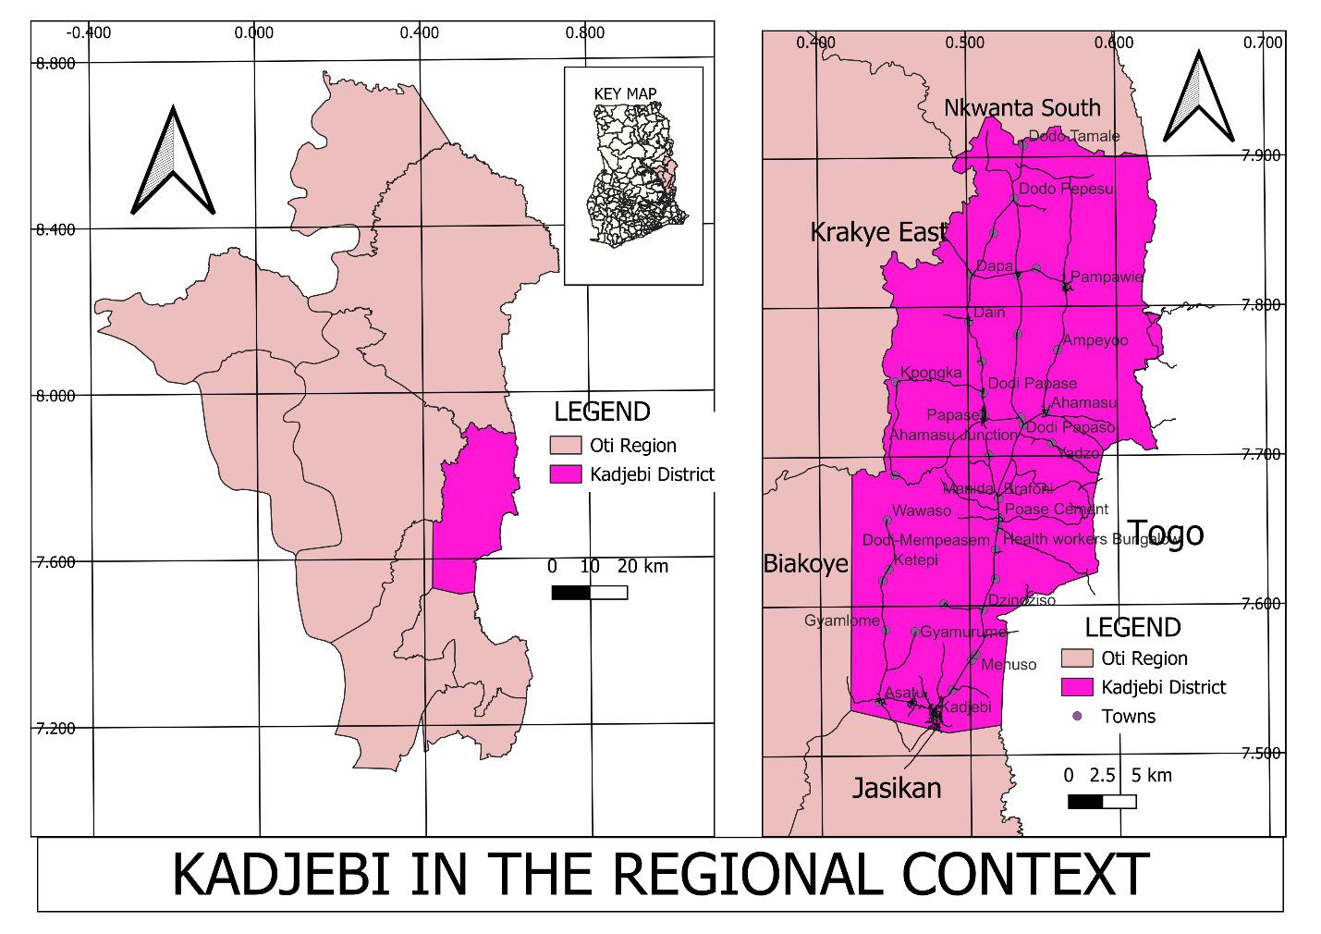
Source: Physical Planning Department, KADA.

Geology And Soils
The district is predominantly underlined by the Buem formations which form 70% of the total rock. The Togo series occurs on the eastern sides of the district to form the remaining 30% of the sub terranean structure. The district is made of quartzite, phylites, arkose, shale and sandstone. There are also traces of deposits of iron ore in the district with alluvial gold deposits on the banks of river Wawa and clay deposits at Asato, Dodo-Amanfrom and Kadjebi. The most predominant type of soil found in the district is the forest ochrosol. This soil includes the alluvial loams which are found along the three major rivers in the district. The soil supports the cultivation of agricultural crops such as ginger, cocoa, oil palm, cashew, plantain, cocoyam, cassava, yams, maize and rice.
Climate
The climate in the district is characterized by an average monthly temperature of about 25oC and rainfall is between 1400 mm and 1800mm. Rainfall is generally heavy and starts from late February/March and ends between October and November each year. The peak of rainfall occurs in June. These conditions are conducive to agriculture production. One major climatic problem, facing the district is severe rainstorms, which destroy farm crops, buildings and also cause severe soil erosion in some parts of the district. Also, the prolonged drought during the dry season (November/December–February/March) is a major source of worry to farmers who are engaged in dry season agriculture production especially vegetables.
The Kadjebi district especially in the rainy season is generally green with trees covering the beautiful landscape of mountains, hills and valleys. 90% of the district total land size is predominantly covered with secondary rain forest. The forests have economic trees such as wawa, mahogany, odum, red wood, raffia palm and bamboo grooves to support the wood processing industry. Animal and bird species such as antelopes, monkeys, grasscutters, weaverbirds and parrots inhabit the forest. The forest reserve with its animal and bird species is potential for eco-tourism development in the district. Meanwhile, bush fires are predominant in the Kadjebi District and this is a major activity that affect the proper growth and functioning of the forest and the wood industry within the district.
Demographic Characteristics
Population Size and Growth Rate
Kadjebi District according to the Ghana Statistical Service’s 2021 population and housing census has a total population of 73,959. This is composed of 37,902 males and 36,057 females representing 51.2% and 48.8% respectively with a growth rate 2.9%.
Spatial distribution of Population
The district is comprised of 87 communities. 68% of these communities are rural whiles 32% are considered urban. Holding other factors constant, the urban communities/localities are Kadjebi; the district capital, Dodo-Amanfrom, Ahamansu, Poase Cement and Dodi Papase. It is estimated that about 30% of the population in the district live in settlements of less than 600 persons. By implication these small settlements cannot support certain social infrastructure by themselves.
Population Density
According to the 2021 Population and housing census, about 73,959 people currently occupy a land area of 949 km2 with the population density as low as 78 persons per a square kilometer.
Household sizes/Characteristics
According to Ghana Statistical Service (2021 PHC), there are 10,623 houses and 13,303 households with an average household size of 5.3 and a large household size of 9.5 in the Kadjebi District. These household indicators therefore account for the corresponding high household expenditures on food, transport, clothing, education and health services in the district. Meanwhile, separate and compound houses are the main type of dwelling units in the district.
Age-Sex Structure
The age structure of the population indicates that, children (0 – 14 years) and old age (65 + years) as the base of the dependency ratios is 40.5% and 5.4% respectively in the district. This simply means that about 54.1% of the population provides the needs of the dependent population of 45.9% who are mostly made up of children and the aged. Details of the Age-Sex structure is provided in Table 1.1 below:
Table 1: Age Distribution of Population by Sex
Age group | T o t a l | M a l e | F e m a l e
0 – 4  5 – 9  10 – 14  15 – 59  60 – 64  65 - 69  70 + | 9,318  11,094  9,541  38,459  1,553  1,479  2,515 | 4,780  5,691  4,895  19,729  797  759  1,290 | 4,538  5,403  4,646  18,730  756  720  1225
Grand Total | 73,959 | 37,902 | 36,057
KADA, DPCU, 2025.

Culture
Ethnicity
Kadjebi district is ethnically diverse. It is predominantly a settler district. Only 19.4% of the population is made up of indigenous Akan. 47.5% of the population is made up of Ewes and the remaining 33.1% is shared amongst the Kotokoli, Basari, Guans, Ga-Adangbe, Mole Dagbani etc.
Language
The Akan and Ewe languages are the predominant language spoken in all the major communities in the district and at all social gatherings and state functions. Other/widely spoken languages include Hausa, Kotokoli and Chamba/Basari. The English Language is also spoken among government officials and other literates.
Traditional Set-up
The indigenous Akan group has eight (8) Traditional areas, namely: - Kadjebi, Asato, Dodi, Dodo, Dapaa, Ampeyo, Pampawie and Ahamansu. Each Traditional area has a Paramount Chief, Divisional chiefs, Queen Mother and Chief Linguist. The settler groups have Headmen who normally pay homage to the Paramount chiefs.
Festivals
There are two major festivals celebrated by the Akans in the district. The Kwasidae Kese or Kuntukunu festival celebrated by the people of the eight (8) Traditional areas. It comes off on Sunday, the last forty-two (42) days to the end of the year. The Dawurokese festival is celebrated by the people of Kadjebi in every three (3) years. The Fontonfrom, Adowa, Kete and Ositi drums are played at such celebrations. The significance of the festivals is to bring together chiefs and people of the traditional areas to assess past performances and raise funds for the support of development programmes and projects of the areas.
District Economy
Agriculture
Agriculture production is the predominant sector of the district economy in terms of employment opportunities and incomes. The residents of the district who are predominantly rural provide the maximum contribution to the district’s share of food security. Agriculture production is, however, small-scale and characterized by low output per farmer.
Local Economic Development (LED)
The Kadjebi district is predominantly an agricultural producing District. The district which is rural in nature is characterized by the availability of large tracts of land for farming and average soil fertility which support the cultivation of crops like cassava, yams, cocoyam, plantain, maize, cocoa ginger and oil palm. The district has a wide range of economic potential, these ranges from agro-processing industries to financial institutions. These include; oil palm plantation, palm fruit processing, farming, wood processing, banking, insurance, credit unions etc. These resources/activities offer economic and financial benefits to individuals, businesses and the district at large. Just like the social resources, the district has not fully exploited these resources for socio-economic development, hence moving forward, these associations could be encouraged to pick up task that will particularly boost revenue generation in the district.
Rural Transport Infrastructure
Accessibility to major agricultural food production communities within the district is a major challenge. Food producing communities such as: Dika, Olobobi, Bisakrom, Tarikorkor, Bethel, Koru, and Butabe are not easily accessible by vehicular transport. Available data from the District’s Agriculture Directorate revealed that, feeder roads in some of the areas only lack simple bridges across streams and rivers. Most of the roads are bush track roads, which are badly eroded and cannot provide access to vehicles, power tillers and trailers. The poor road conditions have resulted in the transportation of food by head portage in most parts of the district. Furthermore, the transport of agriculture produce by head portage is expensive. It is therefore restricted to goods of small quantities that could be transported at a time. This results in to high post-harvest loses and encourages farmers to further reduce the size of their holdings.
Agro-Processing
Agro processing is the most predominant and most important industry in the Kadjebi district. Agro-based industries include cassava processing into gari, cassava dough and kokonte, soap making, local gin (akpeteshi) distilleries, oil palm extraction, pepper processing and palm wine tapping. There are small-scale industries normally managed at the household level, except for cassava processing which required milling/grating machines, and maize sheller for easy shelling, the rest is straight forward industries requiring rudimentary accessories, which can be found locally. The Agro-based industry therefore attracts a large proportion of farmers in the district. Most of the women are engaged in cassava processing, palm oil extraction, soap making and cassava chip production whilst the men are usually engaged in gin distilling.
Forest/Wood Processing Industries
Forest and wood processing include saw milling, carpentry and joinery and charcoal burning. The district is endowed with forest products which feed the six (6) saw mills located at Ahamansu, Titiaka, Dodo-Amanfrom, Dapaa, Kadjebi and Menuso. Currently, wood processing supports local housing and furniture industries in the district. The wood processed by the saw-mills into lumber and plywood are exported to Lagos in Nigeria, Togo, Benin and all over Ghana.
Metal Industry and Auto Works
There are auto works which offer employment to a number of the youth in the maintenance of a fleet of transport vehicles in the district. There are also metal woks such as steel bending, black-smithing in places like Kadjebi where there is electricity. Local farm implements like hoes, axes and cutlasses are fabricated in the district. The installation of a three-phase electricity in Kadjebi is expected to improve industrial production in the district.
Handy Craft/Art based industries
Carvings, basket making as well as kente weaving are undertaken in some localities in the district. Dress making and tailoring, shoe making, solar lamp manufacturing is undertaken in most towns and villages in the district.
Rural Transport Infrastructure
Accessibility to major agricultural food production communities within the district is a major challenge. Food producing communities such as: Dika, Olobobi, Bisakrom, Tarikorkor, Bethel, Koru, and Butabe are not easily accessible by vehicular transport. Available data from the District’s Agriculture Directorate revealed that, feeder roads in some of the areas only lack simple bridges across streams and rivers. Most of the roads are bush track roads, which are badly eroded and cannot provide access to vehicles, power tillers and trailers. The poor road conditions have resulted in the transportation of food by head portage in most parts of the district. Furthermore, the transport of agriculture produce by head portage is expensive. It is therefore restricted to goods of small quantities that could be transported at a time. This results in to high post-harvest loses and encourages farmers to further reduce the size of their holdings.
Tourism Potentials
The Kadjebi District has a number of sites of historical, cultural, scenic and ecological importance for the promotion of tourism. These include: i. The Fetish Shrine at Totto Hill (Dodo Traditional Area), ii. Stone Pillar found at Nyonku No. 1, 3km North-East of Dodi-Papase, iii. Stone cave which is found at Bakpa, 6.5km West of Papase, iv. Obuletey cave located 7km North-East of Asato Menu Range Hills, v. Embroided Inscription on a rock found at Butabe, vi. Crocodile Pond found at Koru and vii. River confluence at Asuboe.
Service Providers
Banking and Non-Banking Financial Services
Banking facilities are expected to promote trade and commerce in the district. The banking facilities available are Ghana Commercial Bank and North Volta Rural Bank both located at the District Capital, Kadjebi. The North Volta Rural Bank has a branch at Dodi-Papase.
Tele-communication
The District Capital, Kadjebi and other towns such as Dzindziso, Mempeasem, Ahamansu, Dodi-Papase, Dodo-Amanfrom, Dodo-Tamale and Pampawie and villages have been connected on to the Tele-communication Net Works of MTN, Tigo, Vodafone and Airtel. The presence of these networks, offers the opportunity for people to reach out to others within and without the district. There are also the Ghana Post Services, Information Centre and ICT centers at Kadjebi and Dodi-Papase.
Data from the DPCU (2025) indicates that only 60% of communities in the district have access to telecommunication networks, with less than 20% enjoying reliable internet services. Within the planning period, it is projected that about 90% of communities will gain access to quality telecommunication networks to support socio-economic development. Currently, most rural areas rely on rural telephone services with very limited coverage, while some communities remain completely cut off due to the absence of network connectivity. During the Assembly’s community engagement sessions, over 70% of communities identified improved network access as one of their most pressing needs, underscoring the urgency of expanding telecommunication infrastructure across the district.
Governance
The Kadjebi District Assembly is charged with the task of programme formulation, budget preparation and promotion of development activities within the Kadjebi District. It has 36 elected members from 36 electoral areas and 16 government appointees with a town council and five (5) area councils, namely Kadjebi Town Council, Asato Area Council, Ahamansu Area Council, Dodo Area Council, Dodi Area Council, Amanta Area Council and 34-unit committees. These Town and Area Council represent the sub-structure of the Kadjebi District.
Development through good governance in the Kadjebi District is vigorously pursued through a partnership between the Kadjebi District Assembly and other development partners such as Non-Governmental Organizations and Non-Decentralized Departments. The Assembly also engages the citizenry through various fora and seminars, prominent among such avenues are the Planning and Budget preparations, Town hall meetings, Sub-Committee meetings, General Assembly Meeting amongst others.
Sub Committees
The Kadjebi District Assembly as part of its structure is grouped into five (5) sub committees. These sub committees include: i. Finance and Administration, ii. Development Planning, iii. Social Services, iv. Justice and Security, v. Works Sub-Committee. These sub-committees are saddled with the responsibility of deliberating on specific issues and submitting their recommendation to the Executive Committee, which in turn presents them to the District Assembly for ratification. The Chairmen of the five (5) sub committees of the District Assembly are members of the Executive Committee.
Social Services
Health Care
The health delivery system in the district is well planned and organized. This makes it easier for communities to access at least a health facility within the radius of 5 km which is recommended by the Ghana Health Service. Meanwhile, the District is experiencing a significant shortfall in health infrastructure relative to its growing population. Based on the 2021 Population and Housing Census (73,959 people), it is estimated that the district requires at least 36 functional health facilities to adequately serve its residents. However, only 25 facilities exist, comprising one faith-based hospital at Dodi-Papase, five health centres, and 19 CHPS compounds. This leaves a gap of 11 facilities, with the situation worsened by the stalled Agenda 111 hospital project, which, if completed, could greatly reduce pressure on the lone existing hospital. The district has the following health facilities as shown in the map and table below:
Table 2: Health Facilities in Kadjebi District
Type of Facility | Public | Private | Location
Hospital | 1 | - | Dodi-Papase
Health Centre | 5 | - | Kadjebi, Pampawie, Dodo-Amanfrom, Poase-Cement, Ahamansu
Health Clinic / CHPS | 19 | - | Dzindzinso, Dodo Pepesu, Wawaso, Dzamlome, Ampeyo, Asato, Yadzo,Dapaa,Bethel, Kponkpa, Akum,Dodi-Mempeasem, kuro, Dodo fie etc.
Source: District Health Directorate, Kadjebi.
Figure 2: Spatial Representation of Health Facilities in Kadjebi District
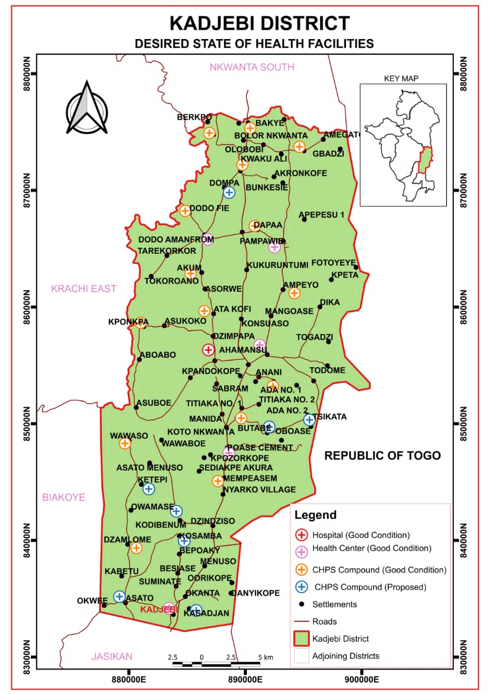
Source: Spatial Planning Department, Kadjebi.
Table 3: GHS Sub-Districts in Kadjebi
Sub-District | Communities | Proportion (%) | 2015 | 2016
Kadjebi Asato | 21 | 32 | 21,748 | 22,008
Dodi | 23 | 25 | 16,774 | 17,193
Dodo | 18 | 20 | 13,419 | 13,754
Ahamansu | 15 | 16 | 10,736 | 11,004
Pampawie | 10 | 7 | 4,697 | 4,814
Total | 87 | 100 | 67,095 | 68,773
Source: District Health Directorate, Kadjebi.

Education
Kadjebi District has various educational institutions which cater for different categories of the school going population. These include institutions for pre-school, primary, JHS and secondary education in the district and grouped into the 8 educational circuits for effective supervision. These are Kadjebi, Asato, Ahamansu, Dzindziso, Poase Cement, Dodo Amanfrom and Pampawie. The Kindergarten, Primary and the Junior High Schools do not have an adequate supply of furniture. The infrastructural status of the schools in the district has however, improved.
Table 4: Educational facilities in the Kadjebi District
 | Planning Standards |  |  |  | Details on Conditions in the District
Level | Enrolment Per Class |  | Population to be Serviced |  | No. of Schools | Total Enrolment | Class Blocks Expected | No. of class blks Avai | No. with Decent Struct | No. with dilap Struct/No. Under Trees | Gap
 | Max | Min | Min | Max
KG | 40 | 50 | 1,000 | 5,000 | 68 | 2816 | 71 | 50 | 40 | 21 | 31
Primary | 40 | 45 | 1,500 | 6,000 | 68 | 10632 | 71 | 55 | 50 | 15 | 16
JHS | 30 | 35 | 5,000 | 10,000 | 52 | 4520 | 54 | 43 | 43 | 9 | 9
SHS | 32 | 35 | 10,000 | 20,000 | 3 | 4195 | 122 | 79 | 72 | 7 | 60
Source: District Directorate of Education, Kadjebi.

Figure 3: State of Educational Facilities in the Kadjebi District
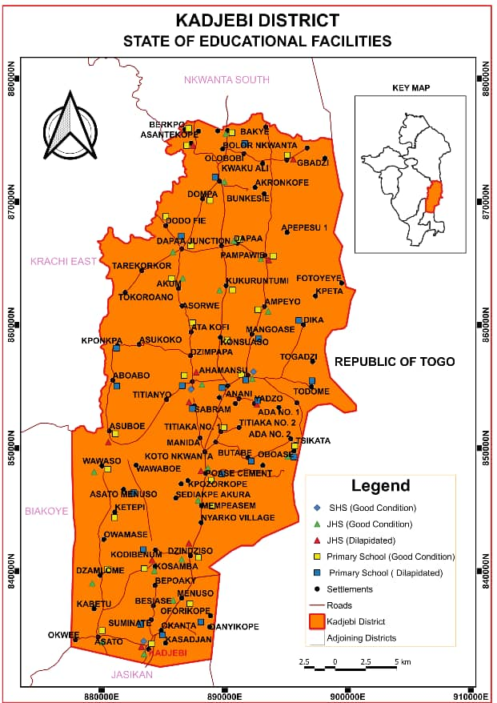
Source: Spatial Planning Department, Kadjebi.

Water and Sanitation
Data available indicates that the district currently has 220 boreholes, of which 88 require rehabilitation. The district also has seven (7) Small Town Pipe Systems in operation. However, a major challenge lies in the high number of non-functional facilities. The pressing need is to identify and address the causes of breakdowns, which may include poor maintenance, overuse, and inadequate community ownership. Priority should therefore be placed on the rehabilitation of existing boreholes and the institution of effective management and maintenance systems to ensure long-term sustainability of water facilities.
Sanitation coverage in terms of public and private latrines availability in the district is 39% as at 2017. With the projected population of 85,899 by 2025, and for the purpose of this planning period, the aim is to increase basic sanitation coverage to 64%. The issues as mentioned above are represented spatially in the map below:
Table 5: Water Facilities in the District
Facility/Type | Population Threshold | No. Expected | No. Available | No. Functional | No. Non-functional | Gap
Hand dug well | 73 – 300 | 88 | 220 | 123 | 97 | 97
Borehole | 300 | 249 | 220 | 132 | 88 | 29
Small Town Pipe System | 2001 – 5000 | 14 | 7 | 6 | 1 | 8
Pipe System | Above 5000 | 5 | 2 | 2 | 0 | 3
Source: DPCU, 2025.

Figure 4: Spatial Distribution of Water Facilities in the District
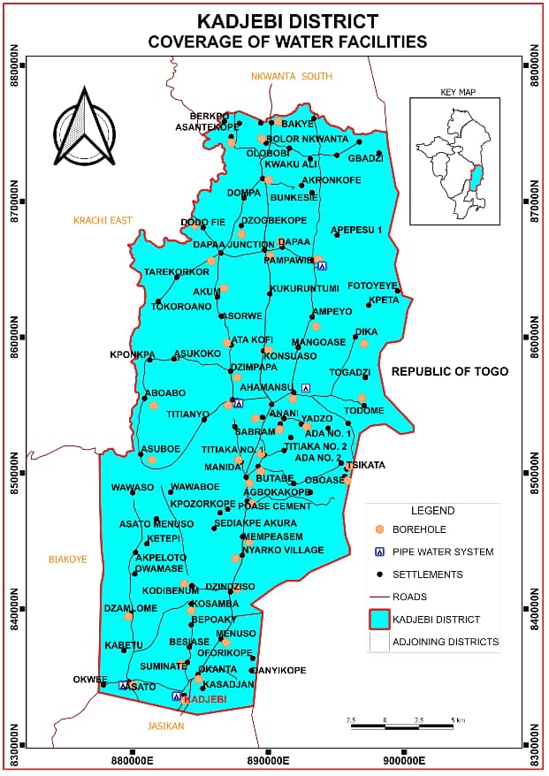
Source: Physical Planning Dept, Kadjebi.

Vulnerability Analysis
Under the current decentralization programmed and the national poverty reduction strategy, District Assemblies are to institute programmes and implement projects that will empower vulnerable groups within their jurisdiction. These groups of people include children, women, the aged and the physically challenged persons. They are also to provide facilities to enhance good community life. Kadjebi District has a Social Welfare Department, which oversees, and co-ordinates all activities that promote good community life.
Electricity
Data from the DPCU (2025) shows that approximately 80% of communities in the district are connected to electricity, while the remaining 20% are yet to be linked to the national grid. Furthermore, community engagements conducted during the preparation of the 2026-2029 MTDP revealed that many communities still require connection to the national grid, while others face challenges such as the lack of meters. Overall, access to electricity has emerged as one of the most pressing community needs, underscoring the importance of targeted interventions in the plan.
Vulnerability Groups
The vulnerable groups identified within Kadjebi District are;
S/N | Nature Of Vulnerability | Specific Issues of Vulnerability | Areas Most Affected in The District | Vulnerable Group | Age Groups Most Vulnerable | Predominant Sex Most Affected | Level Of Vulnerability | Mitigation Intervention | Collab Inst/Depts/Agencies
1. | Socio-Cultural, Economic | - Child Abuse,  - Child labour,  - Child trafficking,  - Child marriages  - Teenage pregnancy | Kadjebi, Ahamansu, Dodo Amanfrom, | Children | 0-17 | Female | High | Child protection | KADA, SW&CD, BAC, BRC/GEA, POLICE, GASIP, NOCID.
2. | Socio-Economic | - Youth Unemployment  - Lack of skills  - Low access to education at Tertiary level | Kadjebi, Poase cement. Papase, Pampawie Dodo Amanfrom | Youth | 18-35 | Female | High | - Skills Development,  - Access to Job /Job creation opportunities,  - Social Protection  - Scholarships | KADA, BAC, BRC/GEA, AGRIC, MP, YEA, NABCO, NOCID, PROLINK.
 | Socio-Economic | - Unequal access to economic/productive resources,  - 2.Low involvement in decision making  - Domestic violence/Abuse, | District wide | Women | 15 and above | N/A | High | - Skills Development,  - Access to Job /Job creation opportunities,  - Social Protection | KADA, SW&CD, BAC, BRC, POLICE
 | Socio-Cultural | - Poor living conditions  - Inadequate access to healthcare | District wide | The Aged | 60 and above | Female | Medium | - Social Protection  - Advocacy | KADA, SW&CD. GH. POLICE
 | Socio-Cultural, Economic | - Unemployment  - Lack of skills  - Low access to education at Tertiary level  - Inadequate access to healthcare  - Inadequate access public infrastructure  - Stigmatisation | Kadjebi, Poase cement, Dzindziso, Papase, Ahamnsu, Dodo manfrom, Wawasom Dzamlome | Persons Living with Disability | 18 and above | Female | Medium | - Skills Development,  - Access to Job /Job creation opportunities,  - Social Protection  - Scholarships  - Advocacy | KADA, SW&CD. GHS. POLICE, BAC, BRC
 |  | - Inadequate access to healthcare  - Stigmatisation | Kadjebi, Asato, Papase | Persons Living with HIV/AIDS | 18-35 | Female | High | - Social Protection  - Advocacy | KADA, SW&CD. GHS. GAC, TA, RA, KHOFFI
 |  | - Flooding  - Deforestation  - Bush burning  - Drought | Dodo Amanfrom, Dodo Dompa, Dodo Bethel, Berkpo, Obuasi, Butabe, Aboabo, Kpomkpa | Persons Living in Disaster Prone/Risk areas | 0-15 | Male | High | - Education and sensitisation  - Development control  - Afforestation  - Improved drainage system | KADA NADMO, GHS
Source: Social Welfare Department, Kadjebi.

CHAPTER TWO

KEY DEVELOPMENT PRIORITIES
Introduction
The limited nature of resources has necessitated the prioritization of needs according to the desires of the populace in particular, and the district as a whole. It also facilitates the efficient allocation and use of these scarce resources. Further it aids in the determination of the best routes towards achieving set goals and objectives.
List of Development Issues
Table 6: List of Development Issues
Sector | Development Issues
Trade & Employment | - Limited job opportunities for the youth
Trade & Employment | - Limited access to credit facilities for investment purpose
Trade & Employment | - Lack of investment in tourism
Trade & Employment | - Unavailability of industries
Trade & Employment | - Poor market infrastructure
Agriculture | - High cost of agricultural inputs and technology
Agriculture | - Declining interest in farming due to low returns
Agriculture | - Small land holding impeding investment
Agriculture | - Lack of storage and processing facilities
Agriculture | - Lack of irrigation facilities
Agriculture | - Inadequate access to extension services
Education | - Poor quality and condition of educational infrastructure and logistics
Education | - Fallen standards of education at all levels
Education | - High rate of teacher attrition affecting quality teaching and learning
Health | - Inadequate health care service delivery in rural areas
Health | - Poor condition of health infrastructure and facilities
Health | - Inadequate health personnel
Health | - Spread of diseases like malaria, HIV & AIDS etc
Water & Sanitation | - Inadequate solid and liquid waste management systems
Water & Sanitation | - Non enforcement of sanitation and environmental by-laws
Water & Sanitation | - Inadequate latrines in communities and institutions
Water & Sanitation | - Inadequate and unsafe water supply systems
Vulnerability | - Limited support for women, PLWDs, children and other vulnerable groups
Roads & Transport | - Poor road network and conditions especially in the rainy seasons
Roads & Transport | - Inadequate drainage systems
Physical Planning | - Lack of adherence to building and development regulations
Physical Planning | - Lack of enforcement of laws in relation to physical developments
Physical Planning | - Non completion of the street naming system
Physical Planning | - Poor GIS-based land management systems
Physical Planning | - Low level of M&E by the people at the grassroots
Physical Planning | - Low IGF capacity of the Assembly
Physical Planning | - Lack of modern office for the Assembly and Area councils
Environment & Climate Sustainability | - High incidence of environmental degradation
Environment & Climate Sustainability | - Over exploitation of natural resources
Energy | - Inadequate extension of electricity and meters to newly developed communities.
Energy | - Limited access to alternative sources of energy such as solar and related metering systems.
Internet And Telecommunication Services | - Limited network/internet connectivity  - Lack of community based digital information hubs
Peace And Security | - Increased risk of boundary-related conflicts
Peace And Security | - Heightened risk of smuggling and substance abuse

Prioritized Development Issues
Table 7: Prioritized Development Issue
Ranks | Development Issues
1st | Inadequate extension of electricity and meters to newly developed communities.
2nd | Poor condition of health infrastructure and facilities.
3rd | Inadequate and unsafe water supply systems.
4th | Spread of diseases like malaria, HIV & AIDS etc.
5th | Inadequate health personnel.
6th | Inadequate health care service delivery in rural areas.
6th | Limited network/internet connectivity
7th | Poor quality and condition of educational infrastructure and logistics.
8th | Fallen standards of education at all levels
9th | High rate of teacher attrition affecting quality teaching and learning.
10th | Poor road network and conditions especially in the rainy seasons.
11th | Limited access to alternative sources of energy such as solar and related metering systems.
11th | Poor market infrastructure.
12th | Limited job opportunities for the youth.
12th | Unavailability of industries.
13th | Inadequate drainage systems.
14th | Limited access to credit facilities for investment purpose.
15th | Lack of storage and processing facilities
16th | High cost of agricultural inputs and technology
16th | Declining interest in farming due to low returns
17th | Limited support for women, PLWDs, children and other vulnerable groups
18th | Inadequate solid and liquid waste management systems.
19th | Heightened risk of smuggling and substance abuse.
20th | Non completion of the street naming system
21st | Inadequate access to extension services
21st | Inadequate latrines in communities and institutions
22nd | Small land holding impeding investment
22nd | Low IGF capacity of the Assembly
23rd | Non enforcement of sanitation and environmental by-laws
23rd | High incidence of environmental degradation
24th | Lack of investment in tourism
24th | Lack of modern office for the Assembly and Area councils
24th | Over exploitation of natural resources
24th | High risk of boundary-related conflicts
25th | Poor GIS-based land management systems
25th | Lack of adherence to building and development regulations
25th | Lack of community based digital information hubs
26th | Lack of enforcement of laws in relation to physical developments.
27th | Low level of M&E by the people at the grassroots
 | Lack of irrigation facilities

CHAPTER THREE

DEVELOPMENT PROJECTIONS AND GOALS
Introduction
The focus of Kadjebi District Assembly development efforts will be to consolidate the successes gained under the Coordinated Programme of Economic and Social Development Policies CPESDP (2021-2025) - An Agenda for Jobs: Creating Prosperity and Equal Opportunity for All in the areas of health, agriculture, education, water and sanitation, energy and community-initiated projects. Other areas to be given the necessary attention include gender mainstreaming, climate change and green economy, entrepreneurial skills development and management, mobile networks, employment creation, lumbering and illegal chain saw operation, vulnerability issues, child labor, strengthening of sub-district structures, participatory planning and implementation, and disasters.
District Development Focus
To ensure that all citizens within the Kadjebi District, irrespective of their gender, socio-economic status, creed or location, have access to basic human needs and services such as primary health care, quality education, potable water, decent housing, security from crime and violence and ability to participate in making decisions that affect their lives.
District Goal
The development goal of the Kadjebi District Assembly is to improve the quality of life of the people. This could be attained through access to quality education and health care delivery system, expansion of socio-economic infrastructure, improved agricultural production, job creation, effective partnership between the private and public sectors as well as efficient management of the natural resource.
Development Projections
The development projections of the Assembly for 2026-2029 were done in relation to the development issues identified and prioritized. This was to ascertain the additional social, economic and infrastructural services that should be provided within the medium-term in order to achieve both district and development objectives. The additional services required are driven by the projected target population of the district as determined by development standards.
Population Projections – 2026-2030
For the purpose of this plan, the District Planning Coordination Unit (DPCU) has prepared projected population figures for the 2026–2029 planning period, using the 2021 Population and Housing Census (PHC) district figures as the baseline and applying the Oti Regional growth rate of 1.5%. These projections are based on the following assumptions: that the regional population growth rate of 1.5% will remain constant throughout the period, and that the district’s Total Fertility Rate (TFR) of 3.6 will also remain unchanged. The projected population of the district for the period 2026–2029 is presented in the table below.
Table 8: Population Projections of the District
Year | Population | Male | Female | Remark
2021 | 73,959 | 37,902 | 36,057 | Actual
2026 | 80,233 | 40,510 | 39,723 | Projection
2027 | 81,493 | 41,140 | 40,353 | Projection
2028 | 82,757 | 41770 | 40,987 | Projection
2029 | 84,024 | 42,400 | 41,624 | Projection
2030 | 85,293 | 43,031 | 42,262 | Projection
Source: Ghana Statistical Service 2021/DPCU, 2025.
Revenue Source Projections
The revenue projections for the Kadjebi District Assembly is expected to show a steady increase from a baseline of GHS 4.09 million in 2024 to GHS 8.48 million by 2029, with the bulk of funding expected from DACF and DDF, highlighting the Assembly’s continued reliance on central government transfers. While IGF is projected to nearly double within the period, it still contributes a relatively small share compared to external inflows, reflecting a gap in local revenue mobilization.
Donor funding is also projected to grow modestly but remains the least reliable source due to unpredictability. These gaps underscore the risks of overdependence on statutory transfers, which are often delayed or reduced. To mitigate these challenges, the Assembly seek to strengthen IGF collection through improved systems, broaden the revenue base, enhance community compliance, and forge stronger partnerships with development partners and the private sector, while ensuring efficient and transparent use of available resources to sustain growth and finance development priorities under the 2026-2029 MTDP.
Table 9: Revenue Source Projections
Sources | 2024 DEC 31 | 2026 | 2027 | 2028 | 2029
GOG | 10,666.65 | 12,799.98 | 15,359.98 | 18,431.97 | 22,118.37
IGF | 241,064.30 | 289,277.16 | 347,132.59 | 416,559.11 | 499,870.93
DACF | 1,877,404.72 | 2,252,885.66 | 2,703,462.80 | 3,244,155.36 | 3,892,986.43
DDF | 1809683 | 2,171,619.60 | 2,605,943.52 | 3,127,132.22 | 3,752,558.67
Donors | 152770 | 183,324.00 | 219,988.80 | 263,986.56 | 316,783.87
Total | 4,091,588.67 | 4,909,906.40 | 5,891,887.68 | 7,070,265.22 | 8,484,318.27
Source: Finance Department, 2025
Education Projections
The data indicates a significant desk deficit across all educational levels in the Kadjebi District, with the highest gaps recorded at the primary level, where 6,377 dual desks and 4,249 mono desks are needed. At the JHS level, there is a shortfall of 3,693 dual desks and 826 mono desks, while SHS requires 1,702 of both dual and mono desks. The KG level, though relatively smaller, still faces a notable gap of 425 dual desks and 2,427 mono desks, which directly affects early childhood learning conditions. These deficits contribute to overcrowding and discomfort in classrooms, thereby undermining quality teaching and learning. Details of the projections is shown below:
Table 10: Desk Deficit
Level | Dual Desk |  | Mono Desk
Level | Existing Gap | Total Needed | Existing Gap | Total Needed
KG | 425 | 425 | 2,427 | 2,427
Primary | 6377 | 6377 | 4,249 | 4,249
JHS | 3693 | 3693 | 826 | 826
SHS | 1,702 | 1,702 | 1,702 | 1,702
Source: GES First Quarter Report, 2025.
To mitigate these challenges, the Assembly has prioritized the provision of desks through budget allocations in the 2026 plan, mobilize support from development partners and NGOs, and engage local carpenters and artisans in desk production to reduce costs and create jobs. Additionally, this phased distribution plan will ensure that the most critical needs, particularly at the primary and JHS levels, are addressed first to improve the learning environment across the district.

Table 11: Health Projections
Table 12: Health Facilities Projections
Facility | Sphere of Influence | Population Threshold |  | Details on Conditions in the district
Facility | Sphere of Influence |  |  | No. Expected | No. Available | No. Functional | No. non-functional | Gap
Facility | Sphere of Influence | Min | Max
CHPS Compounds | Whole electoral area | - | 5000 | 36 | 36 | 19 | 17 | 17
Health Centre | 10 miles radius from sub-district | 5000 | 10000 | 7 | 5 | 5 | 0 | 3
District Hospital | Entire district | 10,000 |  | 1 | 1 | 1 | 0 | 0
Source: GHS First Quarter Report, 2025
Spatially, health services are unevenly distributed, with most remote communities depending on under-resourced CHPS compounds. The ratio of facilities per 10,000 people is 3.4, far below the estimated requirement of 4.9. The inadequacy forces over-reliance on the only hospital, resulting in congestion, delays in service delivery, and poor health outcomes. Below is a summary of the health infrastructural conditions of the district
Electricity Projections
Projections for the next planning period indicate that access is expected to increase to about 90% through the Rural Electrification Project and other related interventions aimed at enhancing socio-economic development.
Telecommunication
Data gathered by the DPCU, 2025 indicates that, 60% of communities within the district have access to telecommunication network out of which less than 20% have access to quality internet services. It is therefore projected that within the planning horizon, 90% of communities within the district will have access to quality telecommunication network to enhance socio-economic growth.

CHAPTER FOUR

COMPOSITE ANNUAL ACTION PLAN - 2026
Introduction
Following a thorough analysis and review of the district's challenges and opportunities in relation to the overarching district development goal, it has become crucial to design district-specific programmes that will ensure the achievement of the set objectives in 2026. The 2026 Annual Action Plan serves as the implementable document that outlines the actionable programmes, sub-programmes, major activities, timelines, cost estimates, implementation status, and responsible institutions or departments. This plan will be pivotal in guiding the district's development agenda.
To ensure the smooth implementation of the Plan, active participation from various stakeholders is essential. The Departments and Units of the Assembly, along with Non-decentralized Agencies, Civil Society Organizations (CSOs), Non-Governmental Organizations (NGOs), and Private Sector players, will be instrumental in operationalizing the plan. Additionally, Traditional Authorities, Assembly members, youth groups, and other key stakeholders will be integrated into the planning and execution process to ensure that the needs and concerns of all community members are adequately addressed.
By fostering strong collaboration and maintaining open channels of communication between these key stakeholders, the district will be able to mobilize the necessary support from local communities. This collaboration is expected to not only enhance the implementation of projects but also ensure the long-term sustainability of the district’s programmes and initiatives.
Moreover, the district will leverage existing NDPC guidelines on the preparation of the District Medium-Term Development Plan (DMTDP) and the Annual Action Plan to ensure alignment with national policies and standards. In this regard, the following programmes have been packaged as part of the district’s 2026 development agenda.

COMPOSITE ANNUAL ACTION PLAN – 2026
S/N | Objective: To promote sustainable local economic development by enhancing agricultural productivity, supporting small and medium enterprises (SMEs), improving market infrastructure, and creating job opportunities through skills development and investment promotion.
S/N | Programme:
S/N | Project | Location | Timeframe -2026 |  |  |  | Cost |  |  | Project Status |  | Implementing Agency/ Department
S/N | Project |  | Q1 | Q2 | Q3 | Q4 | GOG | IGF | GPSNP | New | Ongoing | Lead | Collabo  rating
Programme: Youth Empowerment and Skills and Business Development programmes
 | Facilitate district-wide enrolment of 200No. youth into certified apprenticeship and vocational skills development programmes | Kadjebi, Ahamansu, Dodo-Amanfrom |  |  |  |  |  |  | 120,00 |  |  | BRC | Agric/ YEA  Trade Associations  CSO
 | Training of 300 youth in short term livelihood skills (Soapmaking, Mushroom farming, Cassava processing, oil palm processing. | Kadjebi, Asato, Kosamba, Menuso |  |  |  |  |  | 40,000 |  |  |  | BRC | Agric/ YEA  Trade Associations  CSO
 | Provision of start-up kits to 50No micro and small-scale businesses | Kadjebi, Wawaso, Mempeasem, |  |  |  |  | 40,000 |  | 760,000.00 |  |  | BRC | Agric/ YEA, Trade Associations
 | Facilitate access to credits facilities such as grant and loan programs to help accelerate businesses | Kadjebi |  |  |  |  |  |  | 8,000.00 |  |  | BRC | Agric/ YEA  Trade Associations  CSO
 | Facilitate the formalization of 200No. businesses with the appropriate authorities (DA, GRA, ORC, FDA, GSA, EPA) | Kadjebi |  |  |  |  |  | 4000.00 | 4,000.00 |  |  |  | KADA
 | Organize 3No. business community/ Stakeholder engagements | Kadjebi |  |  |  |  | 3,000.00 |  | 3,000.00 |  |  | BRC | Agric/ YEA  Trade Associations  CSO
 | Promote tourism and culture through trade shows and festive activities | Kadjebi  Wawaso  Asato |  |  |  |  | 4,000.00 | 4,000.00 | 4,000.00 |  |  | BRC  Central Administration | Trade Associations and National Centre for Culture
 | Establish 2 rice, 2 maize, 3 ginger and other demonstrations on good agricultural practices | District wide |  |  |  |  |  | 6,000 | 7,500 |  |  | DDA | KADA
 | Carryout monthly disease surveillance and other veterinary activities across the district | District wide |  |  |  |  |  | 7,500 |  |  |  | DDA | KADA
 | Carryout crop/plant disease surveillance and support any other PPRSD activities across the district | District wide |  |  |  |  |  | 7,500 |  |  |  | DDA | KADA
 | Support the formation and general management of FBOs and farmer Co-operatives | District wide |  |  |  |  | 4,500 |  |  |  |  | DDA | KADA
 | Facilitate farmers and FBOs access to markets and/or aggregators | District wide |  |  |  |  | 2,250 |  |  |  |  | DDA | KADA
Programme: Climate-Smart and agricultural Sustainability programmes.
 | Support the Feed Ghana Programme (FGP) and other government’s agricultural sector flagship programmes. | District wide |  |  |  |  | 9,000 |  |  |  |  | DDA | KADA
 | Conduct 7No climate-Smart training, demonstrations | District wide |  |  |  |  | 9,000 |  |  |  |  | DDA | KADA  CSIR
 | Organize a two-day training for thirty (30) women in processing and packaging of agricultural produce | District wide |  |  |  |  | 4,700 |  |  |  |  | DDA | KADA
 | Hold a 2-day budgeting session for DDA and Management to budget for activities in the district | District wide |  |  |  |  | 3,500.00 |  |  |  |  | DDA | KADA
 | Carryout data collection and analysis for decision making and also collect monthly market information/data. | District wide |  |  |  |  | 12,000 |  |  |  |  | DDA | KADA
 | Carry out home and farm visits to register farmers and track progress in agricultural development | District wide |  |  |  |  | 38,120 |  |  |  |  | DDA | KADA
Programme: Education improvement Programmes
 | Monitor WASH Programs monthly and Intensify School Health and Hygiene Education | District wide |  |  |  |  | 5,000 |  |  |  |  | DDE | KADA  World Vision
 | Organize annual my First Day at School programmes | District wide |  |  |  |  | 10,000 |  |  |  |  | DDE | KADA
 | Support school sports and cultural activities | District wide |  |  |  |  | 20,000 |  |  |  |  | DDE | KADA
 | Procure and supply 1200 dual desk, for selected basic schools | Kadjebi, Dodi-Papase,  Awudome, Dzindzinso, Dzamlome, Konsuaso, Poace Cement |  |  |  |  | 50,000 |  |  |  |  | Central Admin | KADA  GES
 | Embark on monthly Hop visits to schools across the district | District wide |  |  |  |  | 5,000 |  |  |  |  | DDE | KADA
 | Organize 2No capacity training for head teachers, teachers and staff of educational directorate | Kadjebi |  |  |  |  | 5,000 |  |  |  |  | DDE | KADA
 | Supervision, data collection and monitoring of Teaching and Learning activities at all levels | District wide |  |  |  |  | 5,000 |  |  |  |  | DDE | KADA
 | Identification and Placement of Children with Special Needs into Suitable Educational Institutions | District wide |  |  |  |  | 5,000 |  |  |  |  | DDE | KADA
 | Organize District teachers and Educational Forum with Key Stakeholders and 2026 District best teacher prize award | Kadjebi |  |  |  |  | 10,000 |  |  |  |  | DDE | KADA
 | Inclusion of 12No Schools to the GSFP | Dodi-Papase DA, Ampeyo DA, Dapaa DA, Ketepi DA, Asato RC, Asato EP, Konsuaso, Dodi-Papase EP, Asubuo DA, Mary Theresah RC, Kadjebi RC/EP/LA, |  |  |  |  |  |  | 10,000 |  |  | DDE | KADA
Programme: Academic Readiness and Educational empowerment Programmes
 | Monitor BECE and WASSCE and organise annual mock examinations | District wide |  |  |  |  | 100,000 |  |  |  |  | DDE | KADA
 | Organize quiz competitions and Kiddifest for Basic schools and KGs respectively | Kadjebi |  |  |  |  | 100,000 |  |  |  |  | DDE | KADA
 | Provide material support (uniforms/shoes) and financial support to 50No needy but brilliant students, especially Girls | District wide |  |  |  |  | 100,000 |  |  |  |  | DDE | KADA
 | Establish a 1No Day Care Centre to cater for the children of market women and traders in the Kadjebi Market | Kadjebi |  |  |  |  | 100,000 |  |  |  |  | DDE  SW&CD | KADA
 | Organize 2No training and sensitization for kindergarten teachers, basic school educators, and pupils in selected schools |  |  |  |  |  | 10,000 |  |  |  |  | DDE | KADA
 | Facilitate career guidance in schools |  |  |  |  |  | 10,000 |  |  |  |  | DDE | KADA
Programme: Social Protection programmes
 | Collect and collate data on all PWDs in the District | District wide |  |  |  |  | 5,000.00 |  |  |  |  | DSW & CD, Statistics | KADA
 | Offer financial assistance to PLWDs and care givers of PLWDs including IDs and lepers | District wide |  |  |  |  | 3,000 |  |  |  |  | DSW& CD | KADA
 | Organize 2No advocacy programmes for PWDs | District wide |  |  |  |  | 30,000 |  |  |  |  | SW&CD | KADA
 | Organize sensitization in 10 communities on child labour, trafficking and domestic violence. | Kadjebi, Yadzo, Ahamansu, Todome, Kosamba, Dodo-Amanfrom etc |  |  |  |  | 20,000 |  |  |  |  | SW&CD | NCCE  KADA  NOCID
 | Supervise 6 LEAP payment cycles in the district | District wide |  |  |  |  | 3,480.00 |  |  |  |  | SW & CD | KADA  NHIS
 | Monitor 10 Day care centres in the district | District wide |  |  |  |  | 13,000.00 |  |  |  |  | SW & CD | GES
 | Facilitate the registration and renewal of the aged, LEAP and indigent on NHIS | District wide |  |  |  |  | 3,000.00 |  |  |  |  | SW & CD | KADA/NHIS
 | Support referral case management system | District wide |  |  |  |  | 2,000.00 |  |  |  |  | SW & CD | KADA
 | Mainstream gender issues into the development process of the district | District wide |  |  |  |  | 5,000.00 |  |  |  |  | SW & CD | KADA
 | Undertake skills training and entrepreneurship for women and women group | District wide |  |  |  |  | 5,000.00 |  |  |  |  | SW & CD | KADA
Programme: Healthcare Improvement Programmes
 | Organize 1No capacity building for staff in district health information management systems | Kadjebi |  |  |  |  | 12,000.00 |  |  |  |  | DHS | KADA
 | Organize a two-day training for thirty (30) Community Health Management committees and Community Health Volunteers women in community score card | Kadjebi |  |  |  |  | 4,700.00 |  |  |  |  | DHS | KADA
 | Conduct monthly disease surveillance and facilitate the transportation of samples from the district to designated public health reference laboratories in Accra. | Kadjebi |  |  |  |  | 7,500.00 |  |  |  |  | DHS | KADA
 | Organize 1No. orientation and capacity-building sessions for newly posted health personnel in the district. | District wide |  |  |  |  |  |  |  |  |  | DHS | KADA
 | Organize twelve 12 monthly Health Performance Data Validation Meetings | Kadjebi |  |  |  |  | 14,400.00 |  |  |  |  | DHS | KADA
 | Support Community-based Health Planning and service outreach programmes | District wide |  |  |  |  |  |  |  |  |  | DHS | KADA
 | Facilitate routine health-focused home visits by community health nurses, environmental health officers, and other frontline health workers | District wide |  |  |  |  | 38,120.00 |  |  |  |  | DHS | KADA
 | Implement Tuberculosis case investigation and detection across the district | District wide |  |  |  |  | 7,500.00 |  |  |  |  | DHS | KADA
 | Organize and celebrate 1no. child health promotion and vaccination week celebration | District wide |  |  |  |  | 100,000 |  |  |  |  | DHS | KADA
 | Embark on quarterly HIV/AIDS advocacy Stigma reduction campaigns/activities | Kadjebi |  |  |  |  | 85,692.50 | 10,000.00 |  |  |  | DHS | KADA
 | Support formation and selection of community health management teams and Volunteers | District wide |  |  |  |  | 4,500.00 |  |  |  |  | DHS | KADA
 | Facilitate credentialing of facilities for NHIS status recognition | District wide |  |  |  |  |  |  |  |  |  | DHS | NHIS/KADA
 | Supply of Delivery Beds in Selected CHPS Compounds | Yadzo, Ahamansu, |  |  |  |  | 30,000.00 |  |  |  |  | DHS | KADA
 | Procure and Supply 1No resuscitation table | Ahamansu Health Center |  |  |  |  | 10,000 |  |  |  |  | DHS | KADA
Programme: Sanitation improvement programmes
 | Procure and distribute 4No. refuse containers for selected locations within the district. | Kadjebi Health Center, Kadjebi-Estate Zongo, Dunyokofe, Health Centre, Akposorkordzi |  |  |  |  | 65,000 |  |  |  |  | DEHU | KADA
 | Undertake effective liquid and solid waste management activities | District wide |  |  |  |  | 33,000 |  |  |  |  | DEHU | KADA
 | Organize award scheme for ODF communities | District wide |  |  |  |  | 50,000.00 |  |  |  |  | DEHU | KADA
 | Facilitate communal labour activities across all area councils and in selected communities. | Kadjebi, Asato, Dodi-Papase, Dodo-Amanfrom, Ahamansu, Pampamwei |  |  |  |  | 30,000 |  |  |  |  | DEHU | KADA
 | Undertake disinfestation activities | Kadjebi |  |  |  |  | 60,000 |  |  |  |  | DEHU | KADA
 | Procure and supply hygiene-related tools and materials (waste bins, mops, detergents, gloves, scrubbing brushes, disinfectants, and cleaning buckets). | Kadjebi |  |  |  |  | 80,000 |  |  |  |  | DEHU | KADA
 | Complete the acquisition and ensure regular maintenance of the final disposal site for both solid and liquid waste. | Kadjebi Esorkofe |  |  |  |  | 50,000 |  |  |  |  | DEHU | KADA
 | Review, gazette and enforcement of KADAs sanitation bye-laws | Kadjebi  Ahamansu, Asato, Dodi-Papase |  |  |  |  | 40,000.00 |  |  |  |  | DEHU | KADA
 | Review, update and implement DESSAP | Kadjebi |  |  |  |  | 8,000.00 |  |  |  |  | DEHU | KADA
 | Enforcement of By-laws on Stray animals | District wide |  |  |  |  |  | 12,000.00 |  |  |  | DEHU | KADA
Programme: Environmental and climate Sustainability Programmes
 | Establish 3No. Fire Disaster Volunteer Groups (DVGs) in each Area Council, and conduct 8No. awareness campaigns on the impacts of domestic and bush fires. | District wide |  |  |  |  | 50,000 |  |  |  |  | NADMO | GNFS
 | Acquire and cultivate tree seedlings for distribution to schools, interested groups, and individuals to serve as windbreaks and promote economic empowerment. | District wide |  |  |  |  | 10,000 |  |  |  |  | Central Administration | NADMO  GFC
 | Rehabilitation & Maintenance of 30HA community degraded land with tree/fruit crop (plantations) and embark on a 1No. tree planning for life. | Asato  Pampamwei-Okrakrom  Kadjebi |  |  |  |  | 100,000 |  | 300,000 |  |  | Central Administration | GPSNP
 | Identify emerging disaster-prone areas and implement preventive measures to enhance disaster risk reduction across the various zones | District wide |  |  |  |  | 50,000 |  |  |  |  | NADMO | KADA
 | Organize outreach and sensitization programs through communities, churches, and schools on environmental degradation and the effects of rains, bush, and domestic fires. | District wide |  |  |  |  | 50,000 |  |  |  |  | NADMO | KADA
 | Provision of relief items to affected victims of disaster | District wide |  |  |  |  | 20,000 |  |  |  |  | NADMO | KADA
Programme: Social Infrastructural Improvement Programmes
 | Construction of 1No. 3Unit Classroom Block for Yadzo DA JHS | Yadzo |  |  |  |  | 139,000 |  |  |  |  | DWD | KADA
 | Construction of 1No 6Unit Classroom Block with ancillary facilities. | Awudomekope |  |  |  |  | 187,500 | 5,000 |  |  |  | DWD | KADA  GES
 | Construction of 1No CHPS Compound at Kukurantumi | Kukurantumi |  |  |  |  | 76,086.60 |  |  |  |  | DWD | KADA  DHD
 | Construction of 1No CHPS Compound at Sabram | Sabram |  |  |  |  | 100,000.00 |  |  |  |  | DWD | KADA  DHD
 | Drilling and mechanization of 7No and Repair of 5No. Boreholes in selected communities | Kadjebi EP Primary School, Opposite RC Mission House, Akposorkpordzi, Freetown, Kadjebi Health Centre, KASSEC Area and Papasi New Town |  |  |  |  | 425,000 | 5,000 |  |  |  | DWD | KADA
 | Extension of electricity to selected communities and New Sites. | Ativi Kope, Konsuaso, Adorsi korfe, Basari korfe, Adaklu korfe and Menuso New Sites. |  |  |  |  | 50,000 |  | 50,000 |  |  | DWD | ECG  GRIDCO
 | Reshaping of Feeder Roads in Selected Communities | Menuso - Chevie Korfe, Asato through Gyamlome to Wawaso, Kordibenu Township, Titiaka to Dzogbekope |  |  |  |  | 37,500 | 5,000 |  |  |  | DWD | GPSNP  Roads and Highways
 | Construction of Town Roads from Post Office to Nowell Junction and to Kasajan | Kadjebi |  |  |  |  | 100,000 | 10,000 | 48,000 |  |  | DWD | High Ways
 | Renovation of Ahamansu market | Ahamansu |  |  |  |  | 187,500 |  |  |  |  | DWD | KADA
Legacy Projects
 | Completion of 1No. Lorry Station at Kadjebi | Kadjebi |  |  |  |  | 35,000.00 |  |  |  |  | DWD | KADA
 | Complete the Renovation of District Assembly Hall and DPCU Conference Room | Kadjebi |  |  |  |  | 200,000.00 |  |  |  |  | DWD | KADA
 | Complete the Renovation of 2No. Staff Bangalow’s | Kadjebi |  |  |  |  | 40,000.00 |  |  |  |  | DWD | KADA
 | Complete the Renovation of DC’s Bangalow | Kadjebi |  |  |  |  | 36,000.00 |  |  |  |  | DWD | KADA
 | Completion of 1No. CHPS Compound at Asato - | Asato |  |  |  |  | 50,000.00 |  |  |  |  | DWD | KADA  DHD
 | Completion of 1no. One Story District Police Headquarters (Phasec1, Ground Floor) | Kadjebi |  |  |  |  | 452,174 |  |  |  |  | DWD | KADA
 | Completion of 1No. 3Unit Classroom Block at Mempeasem Islamic JHS | Kadjebi |  |  |  |  | 93,750 |  |  |  |  | DWD | KADA
 | Completion of 1No 6No. Classroom at Olobobi DA Basic School | Olobobi |  |  |  |  | 123,000 |  |  |  |  | DWD | DDE
 | Completion of 1No 3No. Classroom at Dodo-Pepesu DA Basic School | Dodo-Pepesu |  |  |  |  | 94,000 |  |  |  |  | DWD | DDE
 | Completion of 1No 3No. Classroom at Kordibenu-Nyarko DA Basic School | Kordibenu-Nyarko |  |  |  |  | 93,750 |  |  |  |  | DWD | DDE
 | Completion of 1No. Nurses Quarters at Asato Menuso | Asato Menuso |  |  |  |  | 78,000.00 | 5,000.00 |  |  |  | DWD | DHD
Programme: Transport infrastructural programmes
 | Installation and maintenance of street lights & road signage | District wide |  |  |  |  | 25,000 |  |  |  |  | DWD | KADA
 | Institute sensitization programmes on road use regulations among road users | Kadjebi |  |  |  |  | 15,000 |  |  |  |  | DWD | KADA
Programme: Spatial Planning Enhancement Programmes
 | Prepare local plans for selected communities | Kadjebi Zongo, New Site and PAL Area |  |  |  |  | 20,000 |  |  |  |  | PPD | LUSPA
 | Prepare a Spatial Development Framework (SDF) for the district | Kadjebi |  |  |  |  | 30,000 |  |  |  |  | PPD | LUSPA
 | Continue Street naming and property addressing system | District Wide |  |  |  |  | 20,000 |  |  |  |  | PPD | LUSPA
 | Undertake monthly public sensitization programmes on Physical development | District Wide |  |  |  |  | 5,000 |  |  |  |  | PPD | LUSPA
 | Undertake regular site inspection of development activities and Enforce Development Control. | District Wide |  |  |  |  | 3,600 |  |  |  |  | PPD | LUSPA
 | Establishment and furnishing of Public Data Room | Kadjebi |  |  |  |  | 10,000 |  |  |  |  | PPD | LUSPA
Programme: Decentralization, Citizen Participation, Security, and Public Service Integrity programmes.
 | Celebrate National and International Anniversaries/ Days and events (Independence Day, Farmers Day etc) | Kadjebi |  |  |  |  | 30,000 | 10,000 |  |  |  | Central Administration | KADA  GES  DDA
 | Ensure participation of civil societies in M&E activities and other public events | Kadjebi |  |  |  |  | 5,000 |  |  |  |  | DPU  DBU | KADA
 | Organize district based technical support for plan review and collaborate with NDPC to organize regional base draft plan reviews | Kadjebi |  |  |  |  | 14,500 |  |  |  |  | DPU | KADA
 | Organize 4No. Town Hall, DPCU, EXECO, F&a, Sub-Committees, Management, RECL, spatial planning etc. meetings and other public forums. | Kadjebi |  |  |  |  | 100,000 |  |  |  |  | Central Administration | KADA
 | Embark on monthly and quarterly update of District Official Website. | Kadjebi |  |  |  |  | 5,000 |  |  |  |  | MIS  DPU | KADA
 | Embark on monthly Sensitization and Registration of Births and Deaths across the District | District Wide |  |  |  |  | 5,000 |  |  |  |  | Births and Deaths | KADA
Programme: Internal Revenue Generation Programmes
 | Carry out Regular sensitization campaigns on tax obligations | District wide |  |  |  |  | 5,000 |  |  |  |  | DFD  DBU | KADA  GIZ
 | Develop and implement revenue collection plan. | Kadjebi |  |  |  |  | 5,000 |  |  |  |  | DFD | KADA  GIZ
 | Training of Commission collectors at various Area Councils | Kadjebi  Asato  Ahamansu  Pampamwei  Dodo-Amanfrom  Dodi-Papasi |  |  |  |  | 5,000 |  |  |  |  | DFD | KADA  GIZ
Programme: Accountability and Corruption reduction Programmes
 | Organize public education and awareness programmes for the general public on Anti-Corruption | District Wide |  |  |  |  | 50,000 |  |  |  |  | Central Administration | Internal Audit Unit
 | Support 4No. Internal field Audits/monitoring of projects | District Wide |  |  |  |  | 5,000 |  |  |  |  | Central Administration | Internal Audit Unit
 | Hold Quarterly Collaborations with Civil Societies on anti-corruption | Kadjebi |  |  |  |  | 10,000 |  |  |  |  | Central Administration | Internal Audit Unit
 | Strengthen internal control measures to reduce opportunities for corruption. | Kadjebi |  |  |  |  | 5,000 |  |  |  |  | Central Administration | Internal Audit Unit
 | Organize 4No Inter-Service & Sectorial Collaboration & Cooperation System (ISCCS) meetings | Kadjebi |  |  |  |  | 25,000 |  |  |  |  | Central Administration | Internal Audit Unit
 | Involve stakeholders in fee fixing and budget preparations | Kadjebi |  |  |  |  | 50,000 |  |  |  |  | DBU | KADA
 | Prepare and submit 2027 Annual Action Plan | Kadjebi |  |  |  |  | 30,000 |  |  |  |  | DPU | KADA
 | Prepare and submit 2030-2033 MTDP |  |  |  |  |  | 50,000.00 |  |  |  |  | Central Adminitration | KADA
 | Organize 1No. Mid-year review of Composite Annual Action Plan and Budget | Kadjebi |  |  |  |  | 20,000 |  |  |  |  | DPU | KADA
 | Procure and maintain office equipment, logistics and stationery and Sanitation tools and equipment for the Assembly and Area Councils | Kadjebi  Asato  Ahamansu  Pampamwie  Dodi-Papasi |  |  |  |  | 100,000 |  |  |  |  | Procurement Unit | KADA
 | Undertake a monthly update of District Administrative Data | Kadjebi |  |  |  |  | 5,000 |  |  |  |  | Statistics | KADA
Programme: Results-Based Monitoring, Evaluation, and Reporting programmes
 | Prepare and Submit 5No. Progress Reports quarterly and annually. | Kadjebi |  |  |  |  | 20,000 |  |  |  |  | DPU | KADA
 | Organize radio programmes to educate the public on activities of the Assembly | District wide |  |  |  |  | 10,000 |  |  |  |  | Central Administration | KADA
Programme: Capacity Building Programmes
 | Organize Three (3) Capacity Buildings training workshop at least one per quarter- for Staff on Local Government Protocols, Programme Based Budgeting and Planning. | District |  |  |  |  | 10,000 |  |  |  |  | HRD | KADA
Source: KADA, DPCU, 2025.

CHAPTER FIVE

MONITORING AND EVALUATION ARRANGEMENTS
Introduction
This chapter outlines the Monitoring and Evaluation (M&E) framework for assessing development programmes and projects in the District. It highlights evaluation as a key tool for improving decision-making, accountability, and project effectiveness. The chapter also emphasizes participatory monitoring and evaluation (PM&E), which fosters community ownership, transparency, and inclusiveness. Through stakeholder engagement and participatory approaches, the District Planning Coordinating Unit (DPCU) aims to enhance evidence-based planning and sustainable development outcomes.
Evaluation
Evaluation is a critical development tool for enhancing decision-making and providing valuable insights to improve programme and project design and implementation. In this regard, the District Planning Coordinating Unit (DPCU) will conduct Ex-Ante, Mid-Term, and Terminal Evaluations for all projects to assess their relevance, efficiency, effectiveness, sustainability, and impact on the lives of the people, as well as to determine whether the expected objectives, outcomes, and impacts are being achieved.
The Ex-Ante Evaluation will be carried out before implementation to establish the feasibility of proposed programmes and projects. The Mid-Term Evaluation will take place during implementation to measure progress, identify challenges, and provide feedback for re-planning and adjustments. The Terminal Evaluation will be conducted at the end of each programme or project cycle to assess the overall effectiveness, impact, and sustainability of development outcomes.
The responsibility for conducting evaluations rests with the DPCU, which will facilitate the process in a participatory manner. Stakeholders to be engaged include traditional authorities, youth and women’s groups, private sector actors, decentralized departments and agencies, district sub-structures, civil society organizations, vulnerable groups, and development partners. This inclusive approach will ensure ownership, transparency, and credibility of evaluation findings for improved development planning and service delivery.
Participatory Monitoring and Evaluation
Participatory Monitoring and Evaluation could be explained as a process where primary stakeholders actively participate in tracking progress towards the achievement of self-selected or jointly agreed results to draw actionable conclusions. There shall be quarterly meeting to evaluate the performance of the plan.
The monitoring team shall also conduct periodic project site inspection with contractors, consultants, beneficiary communities and other stakeholders. The monitoring report would be disseminated to the public and other stakeholders at workshops and fora. Special interest will be focused on the view and contribution of Assembly members, the traditional authorities, NGOs/CBOs using focus group discussions and one on one discussions. Participatory Monitoring and Evaluation is essential to the development of the district based on the following benefits that is derived:
- It enhances effective implementation of the activities and Programme in the plan
- It ensures a sense of ownership of Programme and activities from the community members.
- Also enhances community participation and boost the self-confidence of community members.
The Participatory Rural Appraisal approach will be adopted to enhance the Participatory Monitoring and Evaluation. It is important that, project managers, DPCU members collaborate with the local community members in order to ascertain the required information for the monitoring and evaluation purposes of the plan.
Information for monitoring and evaluation of activities in the various communities will be acquired through a participatory approach. The following methods or steps will be adopted to enhance the participation of community members in the monitoring and evaluation of activities.
- Sensitize the various unit committees’ members in the various electoral areas to actively participate in the process
- Use maps as part of information gathering process
- Conduct Transect Walks
- Undertake Stakeholder Analysis to ascertain the power dynamics and categorise accordingly.
All these methods are to enhance the compilation of relevant information and improve monitoring and evaluation activities.

CHAPTER SIX

DEVELOPMENT COMMUNICATION STRATEGY
Introduction
Communication forms an important part of the plan preparation, implementation and monitoring and evaluation. It becomes more imperative in an organization where it facilitates the flow of information and understanding between different people through different media. Effective communication ensures clarity of thoughts and expressions and presents a medium through which strong relationship and trust can be established. Guided by the local governance Act 936, 2016 (46) and in connection with the 2026 Action Plan, the district assembly acknowledges the importance of formulating a Communication Strategy to serve as a guide in disseminating information to various stakeholders who have varied interest in the development of the district. Information contained in the Plan needs to be shared and discussed with relevant stakeholders and decision makers.
Purposes
- The Communication Strategy Schedule is intended to create awareness about the 2026 Action Plan. It is to inform all stakeholders about the programmes, sub-programs and activities that the District Assembly intends to implement during the planned period.
- The programs are strategically mapped out to enable the assembly contribute to the achievement of the goal of the National Medium Term Policy Framework 2026-2029.
- There would be greater emphasis on transparency and accountability so as to ensure maximum benefits is derived from the implementation of interventions set out in the plans.
Objectives of the Communication Strategy
The main objective of the Communication strategy is to provide relevant information to stakeholders about the 2026 AAP and to solicit for their support in the implementation and monitoring of the projects/activities. The Communication strategies as outlined in the plan seeks to:
- Create awareness; eliminate any misunderstanding and distortions, and foster greater understanding, appreciation and acceptance of the development plans that have been laid out in the medium-term development plan.
- To develop a process to promote and sustain stakeholder involvement and participation, consultation, support, and collaboration in the development of the district.
- To promote donor orientation, support, involvement, and co-ordination among the Assembly and Non-Governmental organizations.
Strategies for Disseminating Information
The District Assembly shall establish mechanisms to facilitate public communication and access to information in the form of media with the widest public outreach possible in the district which may include; television stations; information communication technology centres; websites; community radio stations; and public meetings. The district assembly would encourage and facilitate means of mass communication including traditional media to reach all stakeholders. Will also undertake advocacy on core development issues such as agriculture, education, health, security, economics and sustainable development
Conclusion
All these programmes and projects will be implemented within the context of best environmental practices to promote green economy and good governance. This therefore calls for investments in all the sectors of the economy to propel and enhance the achievement of the goals and objectives outlined in the Plan which are anchored on the Long-Term National Development Plan goal of (LTNDP, 2018-2057) “a just, free, and prosperous nation with high levels of national income and broad-based social development

